**AUTOMATED ATTENDANCE PORTAL**

**-BY Using RFID and Face Recognition.**

**TECHNICAL FIELD OF INVENTION**

The technical field of invention for this project can be described as "Educational Technology" or "EdTech". This field focuses on the development and implementation of technology-based solutions to enhance teaching, learning, and educational management processes. Specifically, the project involves the development of an Attendance Management System tailored for educational institutions, utilizing technologies such as web development (HTML, CSS, PHP), database management systems (MySQL), and possibly integration with RFID technology for tracking attendance. The project aims to streamline attendance tracking processes, improve data accuracy, and provide administrators with valuable insights through reporting and analytics functionalities. Overall, it falls within the broader realm of educational technology innovation aimed at improving administrative efficiency and student engagement in academic settings.

**BACKGROUND**

The background for this project stems from the need for more efficient and reliable attendance management systems in educational institutions. Traditional methods of taking attendance manually are time-consuming, prone to errors, and often inefficient, especially in large classrooms or institutions with numerous students and teachers.

With the advancements in technology, particularly in the realm of educational technology (EdTech), there is an opportunity to leverage digital solutions to streamline attendance tracking processes. By automating attendance management through software applications, institutions can save time, reduce administrative burdens, and improve data accuracy.

The background also considers the growing importance of data-driven decision-making in education. By implementing digital attendance management systems, institutions can gather valuable attendance data that can be analysed to identify patterns, trends, and areas for improvement. This data-driven approach can lead to more informed decision-making and ultimately contribute to better student outcomes.

Furthermore, the prevalence of digital devices and connectivity in today's classrooms makes it feasible to implement such systems. Students and teachers are increasingly comfortable with technology, making the adoption of digital attendance management systems more seamless.

Overall, the background for this project is rooted in the desire to modernize attendance tracking processes in educational institutions, harness the power of technology for administrative efficiency, and leverage data insights to improve educational outcomes.

**OBJECTIVES**

As we aim to build an automated attendance portal which is on web version to automate the attendance through face recognition. Objectives are as follows-

1. Develop a Robust Face Recognition System.
2. Integrate Face Recognition with PHP Backend.
3. Automate Attendance Tracking Process
4. Ensure Data Security and Privacy.
5. Provide User-Friendly Interface.
6. Support Scalability and Customization.
7. Facilitate Integration with Existing Systems.
8. Ensure Accessibility and Usability.

**FIGURES**

**DATA FLOW DIAGRAMS**

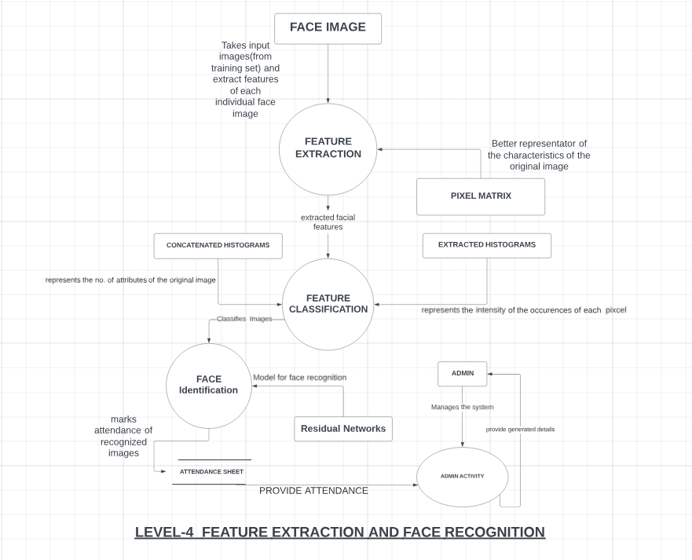

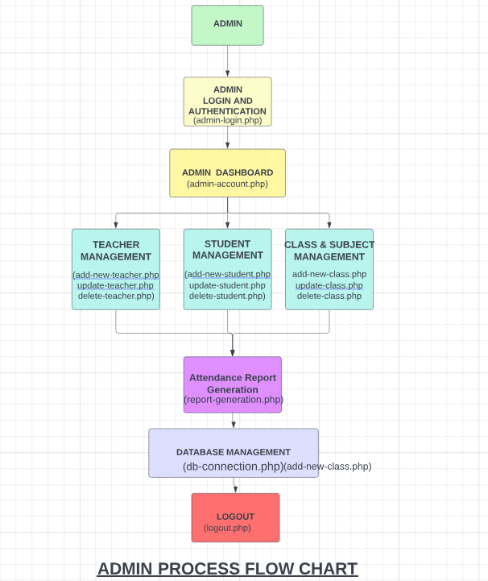

**Fig 2. Process flow diagram.**

**CLAIMS**

* **Efficient Attendance Management**: The project claims to offer an efficient system for managing attendance in educational institutions, reducing the time and effort required for manual attendance tracking.
* **Accuracy and Reliability:** It asserts that the digital attendance management system ensures high accuracy and reliability in recording student attendance, minimizing errors associated with manual methods.
* **Streamlined Administrative Processes**: The project claims to streamline administrative processes related to attendance tracking, including data entry, record-keeping, and reporting, leading to improved efficiency and productivity for staff members.
* **Real-time Monitoring**: It asserts that the system allows for real-time monitoring of attendance, enabling teachers and administrators to promptly identify and address attendance issues as they arise.
* **User-friendly Interface**: It asserts that the system features a user-friendly interface, making it easy for teachers, students, and administrators to access and navigate the attendance management functionalities.
* **Enhanced Security and Privacy**: It asserts that the system prioritizes security and privacy measures to protect sensitive attendance data, ensuring compliance with relevant regulations and safeguarding student information.
* **Improved Student Engagement and Accountability**: Finally, it asserts that the system fosters improved student engagement and accountability by providing visibility into attendance records and promoting proactive participation in academic activities.
* **Integration and Compatibility**: The project claims to be compatible with existing educational management systems and capable of integrating seamlessly into the institution's workflow, minimizing disruption during implementation.

**TECHNOLOGY USED**

The technology stack used in this project have variety of tools and efficient functionalities-

**Programming Languages:**

**a) PHP:** Used for server-side scripting to handle dynamic content and interactions with the database.

**b) HTML/CSS**: Used for creating the user interface and styling web pages.

**c) JavaScript:** Used for client-side scripting to enhance interactivity and validate user inputs.

**Database Management System:**

**MySQL:** A relational database management system used for storing and managing attendance data, user information, and other relevant data.

**Web Development Frameworks:**

**Bootstrap:** Used for front-end development to ensure responsive and mobile-friendly user interfaces.

**Web Server:**

**Apache or Nginx:** Commonly used web servers for hosting PHP applications.

**Session Management:**

**PHP Sessions:** Used for managing user sessions and maintaining state across multiple requests.

**Version Control:**

**Git:** Used for version control and collaboration among developers working on the project.

**Development Tools:**

**a) Text Editors or Integrated Development Environments (IDEs):** Such as Visual Studio Code, Sublime Text, or PHPStorm for writing and editing code.

**b) MySQL Workbench:** For database design, development, and administration tasks.

**Deployment Tools:**

**a) Hosting Service:** Deployment of the application on a web hosting service or server capable of running PHP and MySQL.

**b) File Transfer Protocol (FTP) or Secure Shell (SSH):** Used for uploading files to the server.

**Security Measures:**

**a) Data Encryption:** Secure transmission of data over HTTPS to protect sensitive information.

**b) Input Validation and Sanitization:** Measures to prevent SQL injection, cross-site scripting (XSS), and other security vulnerabilities.

**c) Role-based Access Control (RBAC):** Implementation of access control mechanisms to restrict unauthorized access to sensitive functionalities and data.

**ABSTRACT**

The management of the attendance can be a great burden on the teachers if it is done by hand. To resolve this problem, smart and auto attendance management system is being utilized. But authentication is an important issue in this system. The smart attendance system is generally executed with the help of biometrics. Face recognition is one of the biometric methods to improve this system. Being a prime feature of biometric verification, facial recognition is being used enormously in several such applications, like video monitoring and CCTV footage system, an interaction between computer & humans and access systems presents indoors and network security. By utilizing this framework, the problem of proxies and students being marked present even though they are not physically present can easily be solved. The main implementation steps used in this type of system are face detection and recognizing the detected face.

Automatic face recognition (AFR) technologies have made many improvements in the changing world. Smart Attendance using Real-Time Face Recognition is a real-world solution which comes with day-to-day activities of handling student attendance system.

Face recognition-based attendance system is a process of recognizing the students face for taking attendance by using face biometrics based on high - definition monitor video and other information technology.

It helps in conversion of the frames of the video into images so that the face of the student can be easily recognized for their attendance so that the attendance database can be easily reflected automatically.

This paper proposes a model for implementing an automated attendance management system for students of a class by making use of face recognition technique, by using Eigenface values, Principle Component Analysis (PCA) and Local Binary Patterns Histograms (LBPH) algorithm. After these, the connection of recognized faces ought to be conceivable by comparing with the database containing student's faces. This model will be a successful technique to manage the attendance and records of students.

**REQUIRMENTS-**

* **User Management:**

1) Ability to register new users (teachers, administrators, students).

2) Authentication mechanism for login using username/password or other authentication methods.

3) Role-based access control to manage user permissions (e.g., teachers can take attendance administrators can manage users and classes).

**Class and Subject Management:**

1. Creation, modification, and deletion of classes and subjects.
2. Assignment of teachers to classes and subjects.

**Attendance Tracking:**

1. Ability for teachers to mark attendance for each class session.
2. Option to mark students as present, absent, or late.
3. Storage of attendance records with timestamps and relevant details (e.g., class, subject, date).

**Integration:**

1) Integration with existing student information systems (SIS) or learning management systems (LMS) if applicable.

2) Ability to import/export data in standard formats (e.g., CSV) for interoperability with other systems.

**Security:**

1) Implementation of security best practices to protect sensitive data.

2) Encryption of data transmission over the network (HTTPS).

3) Prevention of common security threats such as SQL injection, cross-site scripting (XSS), and CSRF attacks.

**Scalability and Performance:**

1. Architecture designed for scalability to handle growing numbers of users and attendance records.
2. Optimization of code and database queries for improved performance.

**END USERS**

The end users of this attendance management system project include:

**Teachers:**

* + Teachers are responsible for taking attendance during class sessions.
  + They use the system to mark students as present, absent, or late.
  + Teachers may also access attendance reports and analytics to monitor student attendance patterns.

**Administrators:**

* + Administrators oversee the overall operation of the attendance management system.
  + They manage user accounts, roles, and permissions.
  + Administrators may generate attendance reports for specific classes, subjects, or time periods.
  + They also handle system configuration, data management, and integration with other systems.

**Students:**

* + Students are the subjects of attendance tracking.
  + They may access their own attendance records to monitor their attendance history.
  + Students may receive notifications about their attendance status, such as unexcused absences or low attendance rates.

**Parents/Guardians:**

* Parents or guardians of students may have access to their child's attendance records.
* They use the system to monitor their child's attendance and receive notifications about any attendance-related issues.
* Parents/guardians may communicate with teachers or administrators regarding attendance concerns.

**System Administrators (IT):**

* System administrators manage the technical aspects of the attendance management system.
* They handle server maintenance, database administration, and software updates.
* System administrators ensure the security, reliability, and scalability of the system infrastructure.

**ADVANTAGES**

**Automated Attendance Tracking:**

* The system automates the process of taking attendance, reducing the manual effort required by teachers.
* Attendance can be marked quickly and accurately using digital methods such as RFID scanning, biometric recognition, or online forms.

**Real-Time Monitoring:**

* Teachers and administrators can monitor attendance in real-time, allowing them to address attendance issues promptly.
* Instant notifications can be sent to stakeholders in case of absences or tardiness.

**Improved Accountability:**

* Students are held accountable for their attendance, as their attendance records are accurately recorded and easily accessible.
* Parents/guardians can monitor their child's attendance and collaborate with teachers to address any attendance issues proactively.

**Efficient Record Keeping:**

* Attendance data is stored securely in a centralized database, eliminating the need for paper-based records.
* Historical attendance records are easily retrievable and can be used for audits, compliance reporting, and academic evaluations.

**Scalability and Flexibility:**

* The system can scale to accommodate the needs of small classrooms or large institutions with multiple campuses.
* It can be customized to support various attendance policies, scheduling formats, and educational settings.

**SUMMARY**

The attendance management system is a comprehensive solution designed to automate and streamline the process of tracking student attendance in educational institutions. By leveraging technologies such as RFID scanning, biometric recognition, and online forms, the system enables teachers to mark attendance quickly and accurately. Real-time monitoring capabilities allow educators and administrators to stay informed about attendance status, while comprehensive reporting and analytics provide insights into attendance trends over time. The system enhances communication between stakeholders, promotes accountability among students, and facilitates efficient record-keeping. With its scalability, flexibility, and focus on efficiency, the attendance management system offers a modern approach to managing attendance in educational settings, ultimately contributing to improved student engagement and academic outcomes.

**SUBMITTED BY**–

Mr Anmol Jain (Assistant Professor)

Ansh Srivastava (2000290120028 CS, 6A)

Anand Parashar (2000290120023 CS, 6A)

Antriksh Tyagi (2100290129004 CS, 6A)

Dev Raj Gupta (2000290120062 CS, 6A)